Practical -2: Multiple Views in Power BI Desktop
The three views Report View, Data View, and Model View have different icons available for users.

Report View
You may add several pages while working on Report View. The bottom line shows three pages and if you are willing to add more pages then click on the + sign. A report must have a minimum single page where frequent visualization of data is achievable by selecting the fields onto the canvas.
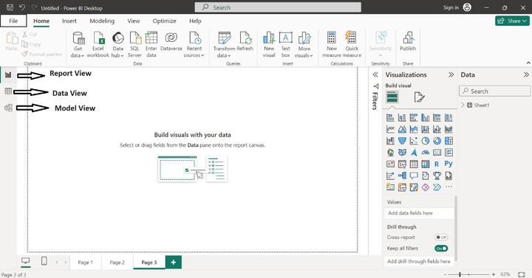

Data View
You can traverse, delve into data, and recognize the data structure in the Data View. The simplest way is to load the data first into this tool and then select the Data View icon to inspect the table. Data manipulation like new measures, formatting, summarization, altering data types, and modifying field names can be employed in the Data View. Sorting and Number filters can also be applied to individual fields of the table.
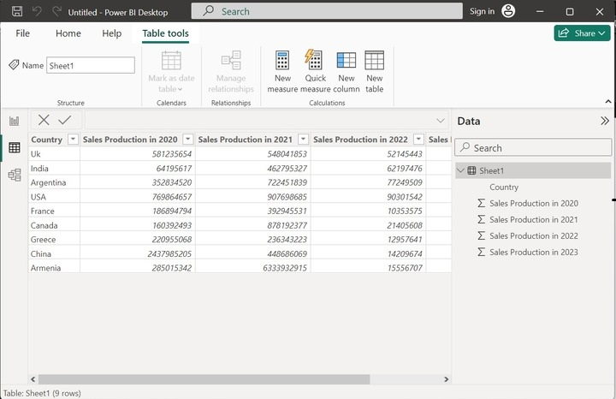

Model View
You can view the relationship between tables, measures, and columns. The simple data model is understandable and easily refreshed by the users. On the other hand, the complex data model is difficult to construct and generalize. It would be recommended to develop the more complicated relationships using the Power query editor to filter the data and reshape the existing model.
